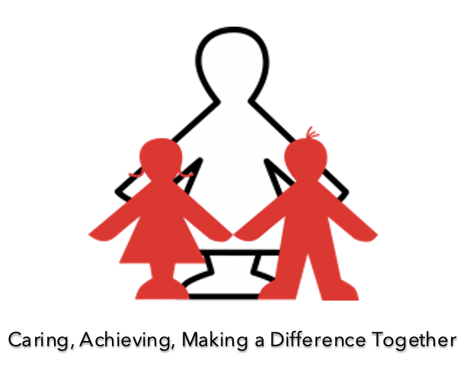
Science at Templemoor Infant and Nursery School
Vision Statement
To stimulate curiosity about our universe, promoting respect for living and non-living things and producing innovative thinkers for the future.
Subject Link to Values

Science promotes our whole school values:

Caring – At Templemoor, we encourage children to use their natural curiosity to ask questions and to investigate how and why things happen. Investigating animal habitats for example enables children to think about how caring for our environment can directly affect not only ourselves, but a much wider world ready to explore.

Achieving – Our Science curriculum is ambitious and aims to give children detailed and connected Scientific knowledge and skills. Children love to ask questions, predict, test, adapt and explain, giving them vital skills to achieve in the future.

Making a Difference – Science helps to prepare children for the developing world. Through the programmes of scientific study, children combine acquisition of disciplinary knowledge (working scientifically) with that of substantive knowledge (scientific knowledge) helping them to gain crucial skills for their own life and the lives of others around them.

Together – Science encourages children to become innovative problem solvers, both as individuals and as part of a team. Many aspects of Science learning are done with a partner or via group work, giving children essential communication and teamwork skills.
Learning Power Links

Science promotes our whole school learning powers:

Resilience: Science promotes the asking of questions and the exploration of ideas, testing out hypotheses, learning from misconceptions and the posing of investigations for the future. Children develop a ‘keep trying’ mindset, moving from set backs to achievement.

Resourcefulness: Science encourages children to work together, using appropriate resources to investigate their own lines of enquiry. Children adapt their ideas based on what they have previously learnt.

Knowledge: Through Science children gain substantive knowledge (scientific knowledge and conceptual understanding) and disciplinary knowledge (aspects of working scientifically). Science teaching at Templemoor complements other areas of learning such as Maths, English and Computing and children develop ways of applying their knowledge across the curriculum.

Keeping safe: Children learn that great scientists are safe scientists. They listen carefully to instructions and learn to explore new ideas safely.

Keeping healthy: Science encourages children to think about being healthy, teaching the importance of exercise for humans, eating the right amounts of different types of food, and good hygiene.

Respectful: Children are encouraged to listen to the predictions of others and to support the development of another person’s ideas. They are encouraged to respect alternative ways of approaching a task and to respectfully discuss findings together.

Rights Respecting Links
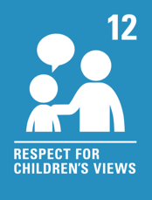
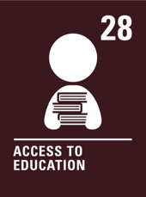
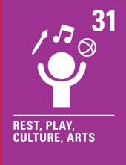
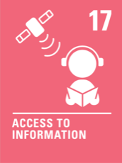
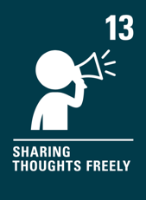

Intent, Implementation and Impact Statement

Intent: Why we teach Science
At Templemoor Infant and Nursery School, Science and the pursuit of ‘finding out’ is central to our curriculum. Being curious and asking questions are fundamental life skills which children can use beyond school and into adulthood. Our curriculum promotes our whole school values – ‘Caring, achieving and making a difference together’.
We aim to create learning experiences in Science that help the children to develop core learning powers – a growth mindset, to enjoy challenge, to persevere, to be respectful, to be resourceful, to be healthy and safe and to develop creativity in all areas. We aim to ensure that pupils leave our school with a clear understanding of these core learning powers and how to demonstrate them throughout their lives.
Running through our Science curriculum is the thread of the UNCRC and we are a Rights Respecting Silver School (RRS). Learning opportunities are built into each unit which help children learn to understand and respect these articles.
Our aim is to inspire children and provide them with skills for life. Pupils will be encouraged to observe closely, to ask and answer questions, to notice patterns, to group and classify, to carry out simple comparative tests and to use secondary sources of information to find things out thus giving children vital skills for the future.
Pupils are encouraged to follow their own lines of enquiry and to create and adapt investigations, considering their own and others’ needs, wants and values. Learning within Science will incorporate other disciplines such as Mathematics, English and Computing.
Through each scientific unit of learning, pupils will learn how to closely observe, become increasingly resourceful in their approach to investigations and think reflectively about why and how things happen. High-quality Science education makes an essential contribution to the innovation, culture, wealth and well-being of the nation. We aim to prepare our pupils for the rapidly evolving world so they are equipped to adapt and adjust the skills they have acquired. As the Ofsted Research and Analysis ‘Finding the Optimum: The Science Subject Report’ says “Science drives innovation, creating new knowledge to help us solve current and future problems.” (Published 2nd February 2023)
Our Science curriculum is based on the Early Years Framework and the National Curriculum. Progression documents have been introduced to build on the knowledge and skills needed to meet the end of Key Stage One objectives in the National Curriculum. Our long-term plan is broad and balanced, allowing children to gain an opportunity to practise and experience a wide range of skills and opportunities.
The key skills we aim to embed are:
- To ask simple questions, recognising that they can be answered in different ways
- To observe closely using simple equipment
- To perform simple tests
- To identify, classify and group things
- Using observations and ideas to suggest answers to questions
- To gather and record data to help with answering questions.

Implementation: How we teach Science
In Early Years, Science is primarily taught through through the Development Matters area ‘Understanding the World,’ however prerequisite skills for scientific enquiry are entwined with the areas of Communication and Language and Personal, Social and Emotional Development. Science investigation is developed through continuous provision and is primarily accessible in the Investigation areas of the EYFS classrooms. Children are actively encouraged to follow their own lines of enquiry and to use resources from around the EYFS unit. Floor books are used to show evidence.
At Key Stage One, the Science curriculum is taught through the use of the White Rose Science scheme of work to ensure coverage of the National Curriculum content and to ensure clear progression. Children are helped to develop their understanding of scientific ideas by using different types of enquiry to answer questions, including observing changes over a period of time, noticing patterns, grouping and classifying, carrying out simple comparative tests and using secondary sources of information to find things out. Children begin to use simple scientific language to talk about what they have found out and develop increasingly detailed ways of recording their findings e.g. tables and simple charts and graphs. Key scientific knowledge will always be taught through the application of working scientifically. Most learning takes place through first-hand practical experiences and is evidenced with photo/video alongside evidence in books.

The Early Years Foundation Stage
In the Early Years Foundation Stage, children’s natural curiosity is welcomed and developed and the early foundations of scientific enquiry are laid. In continuous provision with the addition of tailored enhancements, often fuelled by children’s interests, children are encouraged to follow their own lines of enquiry. Staff will observe children’s learning and guide and direct focus if/where necessary, introducing new vocabulary, gently suggesting new directions to pursue and encouraging simple forms of recording what they find.

Key Stage One
In Key Stage One, teachers build further on the knowledge and skills gained in simple scientific enquiry during the early years. Science is taught weekly as a discrete subject but the skills developed reach into other areas of learning including Maths, English and Computing. Science teaching is topic based using the White Rose Science scheme of work, with high quality, well planned and engaging learning sequences which are designed to demonstrate progression in skills, knowledge and vocabulary. Sessions throughout Key Stage One are delivered using a combination of visual, verbal and practical teaching. Prior learning is vital for skill progression and as children move through school, their knowledge of how to plan an investigation, how to carry out an enquiry, how to record their findings and how to use their new found knowledge develops with increasing levels of detail. Children will use key vocabulary in discussions as well as develop and refine their practical skills.

Impact : What Science gives to our children
Through our Science curriculum we aim to ensure the children leaving EYFS have a greater appreciation for the world around them and the many things they can discover through curiosity and investigation. Children have a wider understanding of scientific enquiry skills and are able to articulate this with growing confidence as they move from EYFS to the end of KS1.

By the end of KS1, children are confident in raising their own questions, planning simple investigations, recording data and drawing conclusions from their findings. Children are encouraged to evaluate their learning to further pursue lines of enquiry.
Through the teaching of Science, we aim to give children confidence in their own learning and the tools required to work independently. Pupils will work constructively by themselves and in partnership with others.
Ongoing assessments take place throughout the year. Assessments are based on teacher judgement, whereby, in each session, any children who are not meeting lesson objectives are noted and targeted for future support in subsequent lessons. These assessments will not only inform future sessions but will also provide an overview of children’s progress within their year groups expected outcomes. Children in Foundation Stage are assessed within Understanding the World and their progress is tracked termly. Age related expectation levels are reported to parents at the end of the Reception year and the end of Year 2.
The use of progression documents for our Science curriculum are such that previously taught concepts are continually revisited and built upon with flashbacks to learning in each session. The use of Learning Organisers for each Science unit taught, clearly state previous learning including vocabulary that ensures that teaching is focused and detailed. Learning Organisers also evidence cross-curricular learning e.g. the use of statistics in Mathematics which leads into the use of simple tables and graphs in Science. Pupil Voice plays an important role in the children’s enjoyment, engagement and development and crucially, within a lesson, children are given time to reflect on their learning, taking part in self, peer and group feedback.
Class teachers in KS1 use Key Assessment Criteria forms, White Rose Science scheme end of unit documents and the Insight tracking programme as a tool to assess the knowledge and understanding of children in Science. Most learning takes place through first-hand practical experiences and is evidenced with photo/video alongside evidence in books. In EYFS, staff use photographs and floor books to gather evidence physical evidence.
Key Concepts

Strand 1: Asking questions

Strand 2: Observing closely

Strand 3: Performing simple tests

Strand 4: Identifying, classifying and grouping

Strand 5: Gathering and recording data

Strand 6: Using observations and ideas to suggest answers to questions
Enriching the Curriculum (Cultural Capital)
- Annual Science Week, including visits from parents who work in STEM subjects, whole school investigations and visits from outside Science companies e.g. Sublime Science.
- Learning about famous scientists, linking to other areas of learning e.g. Design and Technology.
- Close links with the Science TTSA network, drawing on the support and ideas of wider colleagues.

