Templemoor Infant and Nursery School
Nursery Home Learning: Week beginning 8th June 2020

Hello Nursery children and grown-ups! We are sure you will have grown the next time we see you. We cannot wait to see you all.
This half term we will be learning about our exciting new topic ‘How high can you jump?’ We will be learning about our bodies, different sports, different ways our body can move, our senses and keeping healthy.
Thank you so much to those of you who have emailed to show us what you have been learning/making/doing at home. We love receiving emails from you and like emailing you back.
Please email me at homelearningn@templemoor.trafford.sch.uk
Here are this week’s task suggestions. Happy learning!
Subject Area | Task to Complete
Phonics | Just a reminder of the letter sounds we have already learned at Nursery:- m, a, s, d, t, i, n, p, g, o, c, k, e, b, f, l, h and r.  This weeks sound is ‘j’  Kit and Sam are going on holiday. Can you help them pack their suitcase?  Find attached ‘Packing List Matching Game’ What items on the list start with this weeks sound?  Play the initial sounds game powerpoint for ‘j’.  Can you play ‘I Spy’ and find lots of things beginning with ‘j’?
Reading  Speaking and Listening | If you have any stories by Julia Donaldson, read them with your child. Encourage your child to join in with repeated parts of the story.  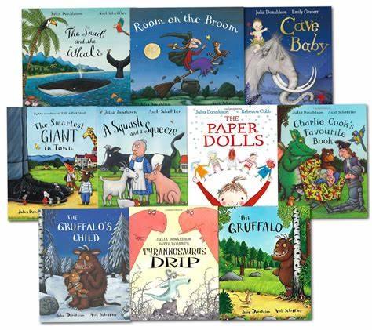  Julia has also written a story called ‘Superworm’ about a very clever and active worm. A link to the book can be found here:  https://www.youtube.com/watch?v=7Jnk3XApKBg  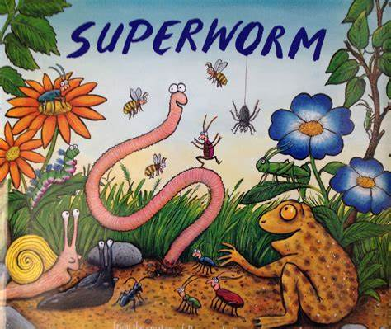  There are many of Julia Donaldson’s stories being read on Youtube. Take a look!  On the BBCiplayer, CBeebies, watch the ‘Something Special episode ‘Aquarium’. Here is the link below: https://www.bbc.co.uk/iplayer/episode/b03xpb5q/something-special-were-all-friends-series-9-16-aquarium  Talk to your child about what is happening and what creatures Justin and his friends see. Can your child learn the sign language for crab?
Writing | Talk to your child about how to write a ‘j’. Encourage your child to write the letter in the air and then try to write some letter ‘j’s’.  When writing the letter the phrase is …  ‘Down his body, curl and dot’  Can you draw a picture of a jack in a box or a jelly and write lots of letter j’s with your picture. You could even try to copy write the word ‘jack in a box’ or ‘jelly’ next to your picture.
Mathematics  Mathematics continued … | This week we are going to look at money. (Please make sure you wash any coins well with soapy water before you use them)  What I would like your child to do is explore the different coins. What colour are they, how are they different, which coin is the biggest/smallest, which coins are circle shapes, which coins are not circle shaped?  Can your child sort the coins in different ways e.g. put all the copper coins together and all of the silver coins together.  If you have 2 of each coin, it would be then great if your child could match the coins.  Please find attached a sheet of the British coins.
Project Work | Make/ collage/paint/ a jellyfish. Send a photograph of your work to the home learning address. We can’t wait to see your wonderful creations!  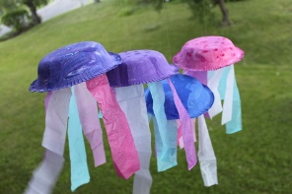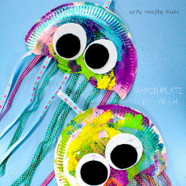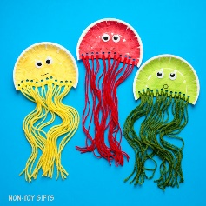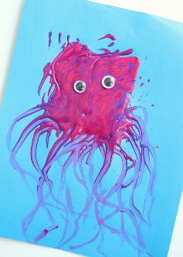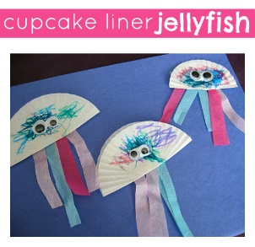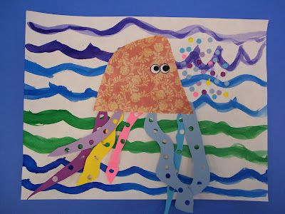
Online Learning | On Youtube watch ‘I’m a jellyfish’ animation and find out about jellyfish. The link can be found here: https://www.youtube.com/watch?v=bvd-kLL99ss
Other tasks to complete | Complete a jigsaw or make your own jigsaw! (Draw a picture and cut it into e.g. 6/8/10 pieces) can a member of your family complete your jigsaw?  Make a jam sandwich (it doesn’t have to be jam!)  Get active, put on your favourite songs and do some movements – jumping, jogging on the spot, star jumps etc.  Make your own jumbo jet (paper aeroplane) See attached sheet for instructions.

