Pirate, princess and den making
A day full of swashbuckling fun!
Princesses and pirates - let’s dress up and conquer the challenges to find the treasure.
Let your imagination go wild with our large den building in and outside, what will it be today, a Pirate ship, a castle?
Activities include:
- Princess dressing up
- Pirate dressing up
- Den making
- Treasure hunt
- Sword and wand making.
- Pirate hats and tiara making
- Pirate and princess story time
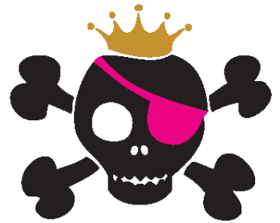

Air day
This day will blow you away!
Bounce the day away on a bouncy castle.
Bubble blowing and bubble wands to make bubbles of all different sizes, see how high you can fly a kite and does the one you made fly?
Activities include:
- Kite flying - weather permitting
- Bubble making
- Bouncy castle
- Balloon modelling / Paper Mache’
- Kite making

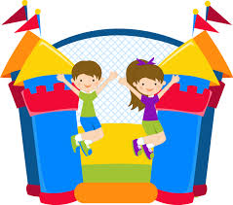

Sports day
Ready, steady, go!
The opportunity to complete an assault course and take part in team races/games.
But the real highlight of the day is the staff vs children football match.
Activities include:
- Assault course
- Egg and spoon race
- Sack race
- Skipping race
- Beanbag race
- Dribbling race
- Staff vs children football match
- A wide range of sports equipment available
- Sports themed craft, including medal making etc.

Quiz and games
Bingo!
Points mean prizes! Today is packed with games, games and more games. Let’s put our teamwork skills to the test.
Activities include:
- Hoopla
- Hook a duck
- Ball target
- Group game of Bingo
- Children's Quiz
- Board games competition
- Large scale games, snakes and ladders, connect 4
