Templemoor Infant and Nursery School
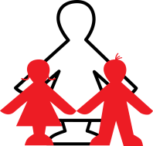
Nursery Home Learning: Week Beginning 22nd June 2020

Hello Nursery children and parents. Welcome to another week of home learning. We do love to see what you are doing and learning at home so please do keep emailing us.
Please email me at homelearningn@templemoor.trafford.sch.uk
Happy learning!
Subject Area | Task to Complete
Phonics | Just a reminder of the letter sounds we have already learned at Nursery:- m, a, s, d, t, i, n, p, g, o, c, k, e, b, f, l, h, j and v.  This week’s sound is ‘y’  Fascinating fact – Did you know that the milk from a yak is pink?  When you are out and about you could look for things that are yellow. Also look for the letter ‘y’ on signs/posters e.g. ‘Stay safe’.  Play the ‘Sorting Sounds’ Powerpoint ‘y’ that can be found on the home learning page.  If you have a printer, print out the ‘y’ workbook.
Reading / Storytelling  Speaking and Listening | Here’s a super story to go with our topic. It’s called ‘The Hare and the Tortoise’. 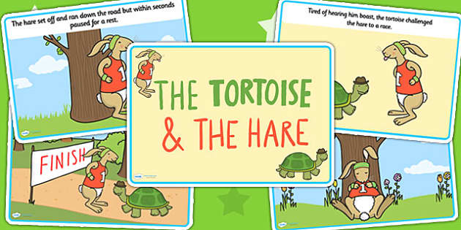  You can find the story on the home learning page.  Be like Tough Tortoise and don’t give up, keep trying!  Muscial Corners game. This game helps children to listen and remember sounds. This game will help your child to listen to sounds at the beginning of words and hear the differences between them.  How to play.  Put a chair in each corner of the room, or outdoors. Collect four sets of objects, each set containing objects with names that start with the same sound. (Four different initial sounds are represented). Keep back one object from each set and place the remaining sets on each of the four chairs. At first, sit with your child. Name each of the four sets of objects, giving emphasis to the initial sound. Explain that now there will be music to move around or dance to and that when the music stops your child needs to listen. You will show them an object and they should go to the corner where they think it belongs.
Writing | Talk to your child about how to write a ‘y’. Using the phrase “Down a horn, up a horn and under his head”  Encourage your child to write the letter in the air and then try to write some letter ‘y’s’. Perhaps they could write the letters in different yellow mark making materials e.g. yellow pencil crayon/yellow wax crayon/yellow felt pen/ yellow chalk.
Mathematics | Have a think about your two feet. What can your feet do and help you to do? E.g. run, walk, balance, jump, hop etc.  Can you draw around everyone’s feet in your family and cut each pair out. Who has got the smallest feet, biggest feet? Can you put the pairs of feet in size order, starting with the smallest to the biggest?  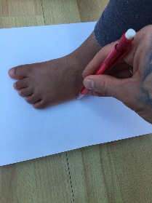
Project Work | Take the challenge! Could you complete these 5 physical challenges every day this week.  - Balance on one foot and count to 5.  - Make a line with chalk or tape – can you walk along it without stepping off the line at all?  - Jump on the spot 5 times.  - Crawl from one side of the room to the other and back again.  - Run on the spot and count to 10.  Make your own Hare and the Tortoise stick puppets and retell the story. You could draw your own characters or print off the ones on the home learning page.
Online Learning | Cosmic Kids Yoga on Youtube. A great way for children to be calm and join in with yoga through stories that they will love. Have a look with your child to find a story they are interested in. Follow the link to take you there: https://www.youtube.com/user/CosmicKidsYoga  Face time a relative. Can you teach them some yoga poses?
Other tasks to complete | Every Friday the nursery children do ‘Sticky Kids’.  Some of the Sticky Kids songs are on You Tube. Some of our favourites are :- Let’s Go Walking, Funky Monkey, Bend and Stretch, Old McDonald, Wash Your Dirty Hands, Zooming to the Moon and the Cool Down.  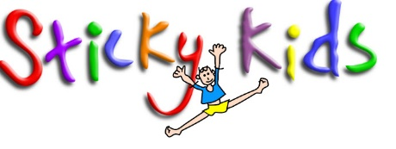  You can find some Hare and the Tortoise themed pencil control sheets on the home learning page. If you don’t have access to a printer you could easily make your own by using a felt pen to create a track for your child to trace over.  Make a den inside or outside, find your favourite teddy and share a book with your teddy. If there is room, invite a grown up into your den to read a story to you.

