Year 1 suggested Home Learning Timetable for the week beginning 8th June 2020
We hope you have all had a lovely rest over the Whit Holiday. Please enjoy having a go at the following activities. You can do them in any order. Happy Learning from Miss Salisbury and Mrs Drinkwater!
Monday 8th June | Tuesday 9th June | Wednesday 10th June | Thursday 11th June | Friday 12th June
Reading  15 minutes listening to and discussing a favourite story. | Reading  15 minutes reading to a grown-up. | Reading  15 minutes listening to and discussing a favourite story. | Reading  15 minutes reading to a grown-up. | Reading  15 minutes listening to and discussing a favourite story.
Phonics  Read Write Inc. phonic lesson-  https://www.youtube.com/channel/UCo7fbLgY2oA_cFCIg9GdxtQ  New live lessons start at 9:30am.  Set 3- u-e/oo/ew sound. | Phonics  Read Write Inc. phonic lesson-  https://www.youtube.com/channel/UCo7fbLgY2oA_cFCIg9GdxtQ  Live lessons start at 9:30am.  Set 3- aw/or sound. | Phonics  Read Write Inc. phonic lesson-  https://www.youtube.com/channel/UCo7fbLgY2oA_cFCIg9GdxtQ  Live lessons start at 9:30am.  Set 3- are/air sound. | Phonics  Read Write Inc. phonic lesson-  https://www.youtube.com/channel/UCo7fbLgY2oA_cFCIg9GdxtQ  Live lessons start at 9:30am.  Set 3- ur/ir/er sound. | Phonics  Read Write Inc. phonic lesson-  https://www.youtube.com/channel/UCo7fbLgY2oA_cFCIg9GdxtQ  Live lessons start at 9:30am.  Set 3- er sound.
English  Please continue to use the home learning lessons produced by BBC Bitesize. https://www.bbc.co.uk/bitesize/tags/zjpqqp3/year-1-and-p2-lessons/1  Please click on 12th May English lesson, ‘Using the word ‘and’ to join sentences’. Watch the video and complete Activity 1, 2 and 3. You could write your ‘and’ sentences in your home learning book. | English  https://www.bbc.co.uk/bitesize/tags/zjpqqp3/year-1-and-p2-lessons/1  Please click on 14th May English lesson, ‘Using exclamation marks’. Watch the videos and complete Activity 1, 2 and 3. You could write your poster on ‘How to stay safe at a pond’ in your home learning book. | English  https://www.bbc.co.uk/bitesize/tags/zjpqqp3/year-1-and-p2-lessons/1  Please click on 21st May English lesson, ‘Writing the days of the week’. Watch the video and complete Activity 1, 2 and 3. You could write a brief diary in your home learning book. | English  Reading comprehension-  Please read together the attached document, ‘All about Hedgehogs’. Then with help from an adult, answer the questions. | English  Reading comprehension-  Please read together the attached document, ‘All about the fox’. There are 3 different reading levels; please select which level your child is most comfortable with. Then answer the questions.
Maths  Pick 5 addition facts from our grid to practise and learn this week (you might link these to matching subtraction facts, e.g. 9 + 3 = 12 // 12 – 3 = 9)  Recognise and name 3D shapes  Discuss what ‘3D’ means. Have a look to see if you can find any of the following 3D shapes around your house:  - Cube  - Cylinder  - Cuboid  - Pyramid  - Cone  - Sphere  If you have any of these different 3D blocks to build with, build a model and then describe it to a grown up (e.g. how many cubes, how many cones, etc.) | Maths  Practise and learn your 5 chosen addition and subtraction facts.  Sorting 3D shapes  Watch the video about sorting 3D shapes using the following link.  https://vimeo.com/420581162  Choose some 3D shapes (these can be real-life examples, such as tins, boxes, balls etc.)  Practise sorting them in different ways, e.g. shapes that roll and shapes that stack.  Can you sort shapes for someone else to guess how you have sorted them?  Complete the activity sheet ‘Sorting 3D shapes’. | Maths  Practise and learn your 5 chosen addition and subtraction facts.  Recognise and name 2D shapes  Watch the video about 2D shapes using the following link.  https://vimeo.com/420581449  Have a look to see if you can find any of these 2D shapes in your house:  - Rectangle  - Circle  - Square  - Triangle  Look at some of the 3D shapes from yesterday – can you spot any 2D shapes on the faces of these shapes? (E.g. circles on a cylinder, squares on a cube).  Complete the activity sheet ‘Recognise and name 2D shapes’. | Maths  Practise and learn your 5 chosen addition and subtraction facts.  Sort 2D shapes  Watch the video about sorting 2D shapes using the following link.  https://vimeo.com/420581566  Choose some 2D shapes from around your house and sort them by name.  What other ways could you sort these shapes? Can you sort them in a way and ask someone else to guess the rule you used?  Complete the activity sheet ‘Sort 2D shapes’. | Maths  Practise and learn your 5 chosen addition and subtraction facts.  Patterns with 3D and 2D shapes  Watch the video about making patterns with 3D and 2D shapes using the following link.  https://vimeo.com/420698416  Use shapes to make some repeating patterns. This might be by drawing 2D shapes, using shaped blocks, or shapes around your house. Encourage children to say their pattern out loud, consolidating shape names.  Have a go at predicting the next shapes in a pattern.  Complete the activity sheet ‘Patterns with 3D and 2D shapes’.
My Happy Mind  Use the ‘myHappymind Parent Kit’ which is on the home learning page of the school website (see * below).  Module 3: ‘Appreciate’ – Complete: ‘What is Gratitude?’  *You can now access these materials direct (including coached breathing exercises). Simply visit: https://myhappymind.kartra.com/page/ParentKitBundle and follow the instructions as outlined in the ‘Happy Minds Parent Kit Information Sheet’ which can be found on the home learning page.  Why not complete a session of Cosmic Yoga? Practice yoga, mindfulness and relaxation techniques. A link to the site can be found here:  https://www.youtube.com/user/CosmicKidsYoga | P.E. – with Joe Wicks (9am if you want to do the session live) https://www.youtube.com/user/thebodycoach1  Go Noodle has some great dance moves that you could try: https://family.gonoodle.com  Computing: Purple Mash (you should have been given a log in – if you need these details again then please email.  admin@templemoor.trafford.sch .uk)  To access Purple Mash:  https://www.purplemash.com/sch/templemoor  and then log in from here.  Click on ‘Mathematics’, then ‘2 Calculate’ and follow the instructions below. | Art  Rob Biddulph has been showing us how to draw characters from his story books. The art tutorials can be found on YouTube. Please enjoy selecting the character(s) you want to draw and email your art work to us. Eugene the owl and Gregosaurus are simple ones to start with. #Draw with Rob https://www.youtube.com/watch?v=ta5cWmlgHBU&t=451s  https://www.youtube.com/watch?v=bhyCxVPb1qU&t=447s | Science  Have a think about special places where creatures might like to live, e.g. crabs in rock pools, rabbits in burrows. Explain that we call these special places habitats.  Explore the outdoors to look for mini-beasts. You might want to take a photo or sketch some of the mini-beasts you find, or use the table to record the mini-beasts and their locations.  Talk about the different habitats you find and their features (e.g. dry, dark, damp). Is there anything that is the same/similar about all the mini-beasts found in a habitat (e.g. small, wiggly). Has anything surprised you about what you have found and where you found it?  Bend over and feel your backbone. Explain that lots of animals have a backbone, but some don't. We often call creatures without a backbone 'mini-beasts' or invertebrates.  For a great clip on minibeasts watch the following link:  http://www.bbc.co.uk/education/clips/z44g9j6 | History  Our new history topic for this next half term is ‘Great Explorers’.  Watch the BBC bitesize video about Christopher Columbus using the following link:  https://www.bbc.co.uk/bitesize/topics/zhpchbk/articles/znchkmn  You could have a look at a map and find America. Can you mark Christopher Columbus’ journey to the Americas on the map? This can be found on the home learning page.  Complete the BBC bitesize activity by ordering the events of Columbus’ story.  Can you write some sentences about Christopher Columbus into your home learning book?

Espresso Log in:
www.discoveryeducation.co.uk
Student Username: student6783 (lower case)
Password: temple

Computing: Session 1
- Explain to the children that we are looking at a type of computer program called a spreadsheet today. Spreadsheets are used for organising information. For example, if you were planning a tea party you could enter into the spreadsheet all the things you will need to get for the party and who you were going to invite. Can they think of any other things that could be stored in a spreadsheet for organising a party? (menus, gift list, entertainments).
- Many people make lists on paper but the advantage of using a spreadsheet is that it can also do calculations for you. Explain what this means e.g. you could enter the cost of the different things that you will need for your party into the spreadsheet and then easily calculate how much money you will need to buy them all.
- The aim today is to open a spreadsheet program in Purple Mash called 2Calculate and to learn how to enter information and do some simple calculations.
- Open 2Calculate. Show that when it starts, there is a smaller screen in the middle with different choices. The labels at the top (‘Sheet’ and ‘Lesson’) are called tabs. For today we are going to click on the ‘Sheet’ tab.
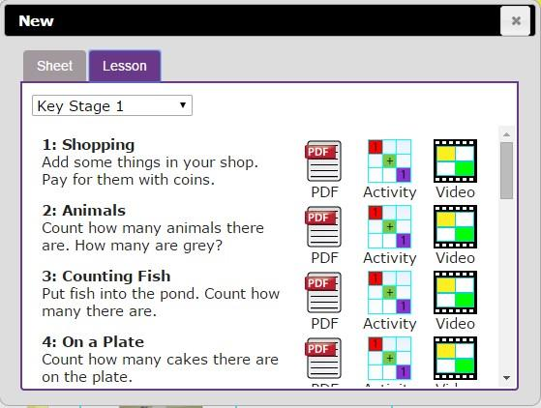

- Click on the tab. This also gives a few choices but for today click on the first one: an empty sheet with big ‘rectangles’.
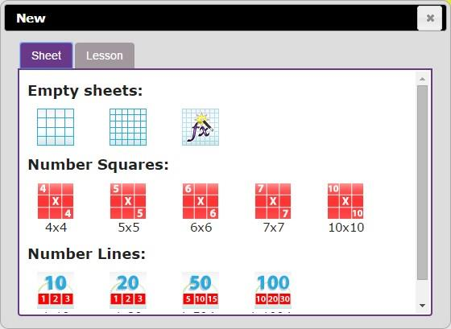
- Spend some time showing children the following things, emphasising the new vocabulary in bold:
- The rows; these are numbered 1 to 6
- The columns; how many are shown?
- The word ‘cells’ is used to describe each box in a spreadsheet.
- Each cell can contain words, numbers, colours, symbols (such as + - =)
- How to move from cell to cell; this can be done by clicking in the cell using the mouse and by using the arrow keys on the keyboard. If you press the enter key when in a cell you will move down 1 row.
- How to type into cells; in 2calculate the writing will get smaller automatically to fit in the words that you type.
- How to delete the contents of a cell; either by using the backspace key or the Delete key. Children should now spend some time opening 2Calculate on their computers and trying moving and typing. Can they enter their name into a cell?
- Once they have managed to do this, show the children how to save a file. They will need to give their file a sensible name that they haven’t used before, why?
- Now see if children can close 2Calculate then open it again and open their file. Let them spend some time experimenting with typing and also colouring cells.
- To colour cells they first click on the cell, then click on the colour they want in the toolbox on the right-hand side.
- If they select more than 1 cell by dragging the mouse over a few cells, then they can colour all of these cells at once.
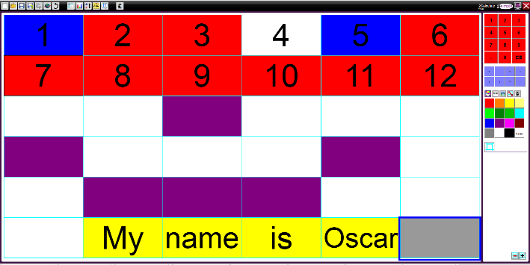

- If the children are getting on well with this, show them how to put a simple sum into the cells and let 2Calculate work out the answer. First enter a number then go into the next cell to the right and click the ‘+’ sign button on the right hand side, then move to the next cell and enter another number. Now put the ‘=’ sign in the next cell and see how 2Calculate works out the answer.
- Children can spend time experimenting with this and performing calculations.
