YEAR 2 – SPRING 1 2018
Imaginative Learning Project - Home Links Learning
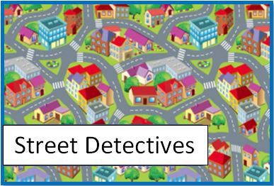

Suggested home learning activities:
The following activities are optional and are intended to support or enhance the skills and knowledge explored throughout the undertaking of the topic. They are not intended to replace the weekly core tasks and spelling/ mental maths tests provided each week.
The optional activities are a list of suggestions that you can do at home if you wish. They can be done at any time. We do not require these to be handed in, although if your child would like to show their work please feel free to bring it to school. We will ensure all work is shared with the class and the children will receive a stamp for completing it!
- Create a 3d model of a place in our local area.
- Go for a walk in your local area and take photos of what you see on your way.
- Design an information leaflet about your local area including shops and buildings of importance.
- Ask a local councillor about our local area and what new changes are going to take place.
- Investigate the growth of plants and flowers in your local area what is growing at this time of year?
- What local buildings have you been to and do you enjoy going to? Take some photos and bring them in to share with the class.

Thank you for your continued support
The Year 2 Team

